Approved 3-24
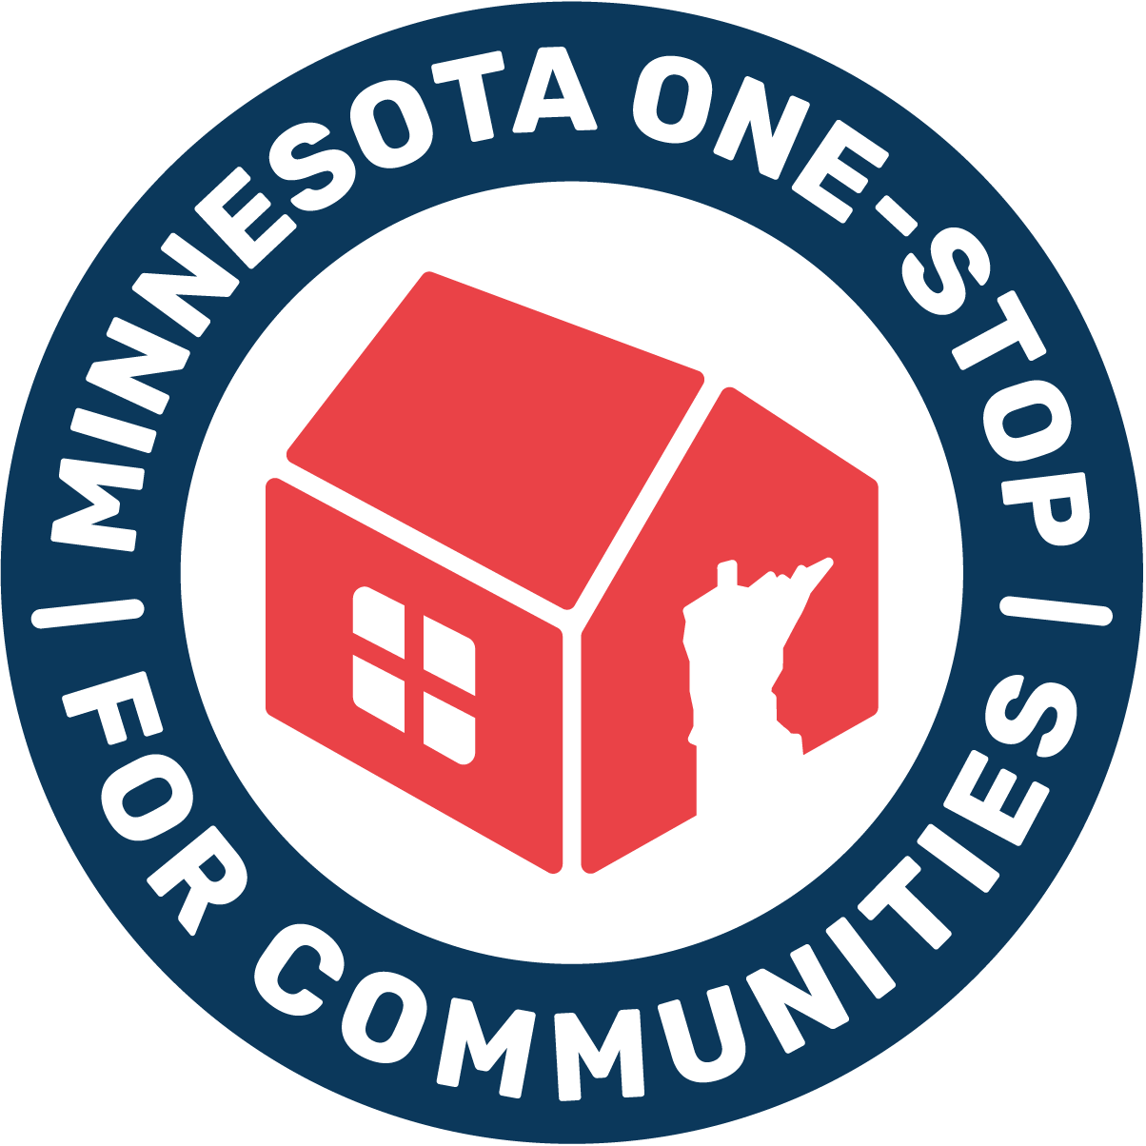
APPLICATION

Minnesota One-Stop for Communities
Board of Directors
Personal Information:

Name: | Date:
Address: | City:
State: | Zip Code:
Phone: | Email:
Occupation: | Employer:
Position (Parent, Grandparent, etc.):

Questions:

- Please describe your community, volunteer, professional experience:

- How do you feel you could contribute as a board member to Minnesota One-Stop for Communities mission to empower and strengthen families?

- Why do you want to be on the Board?

- What else do you want us to know about you?

Please attach resume or bio.
This information will be used on the website and for resource development.
Date Submitted:
Please return application to:
Board Member: Tonya Long
tklong50@gmail.com
(651) 206-0590

Minnesota One-Stop for Communities
Main Office Address: 2277 Highway 36 West, Suite 302, Roseville, MN 55113
612-669-4037 | info@mnonestop.org │ www.mnonestop.org

